Required Python Libraries: matplotlib

For installation help, see https://www.liquidweb.com/kb/install-pip-windows/. If you already have pip installed, find the directory C:\Users\**username here**AppData\Local\Programs\Python\Scripts. Then hold Shift+Right Click and select open command line or open PowerShell. Then type in pip followed by the name of the Python library (eg, pip install matplotlib). If you are working in PyCharm, locate the Scripts folder associated with your given project and do the same installation process.

I. Operation

Once you have a relatively accurate guess for the 4 sphere parameters, use this program to generate a heatmap of the point cloud.

1. Run **lin reg.py**

Before using this program, make sure that you have used **lin reg.py** to generate your sphere parameters. Once you have them, paste them into the **center** variable in the order [xc, yc, zc, rc] (replaced by actual numbers).

1. Sample the point cloud

Slice a segment of points from the point cloud starting from around the lowest elevation sampled for linear regression and ending at the highest. I recommend downsampling to around 400000 points as it provides a detailed heat map without requiring too much time.

1. Run the program and adjust gradient

Depending on what is considered an acceptable value, you may want to change which distances are red and blue or you may want a different gradient altogether. To do this, adjust the **vmin**, **vmax**, **mid**, **s1**, and **s2** variables in line 92 (the class SqueezedNorm is called). Its difficult to explain what exactly each of these parameters does, so have a look at the **colorbar calibration.py** program. By running it, you can adjust **mid**, **s1**, and **s2** with sliders to see how the color distribution is affected. To change **vmin** and **vmax**, see lines 5 and 6 of the same program. Once you have a color distribution that looks adequate, copy your values back over to the **heatmap.py** program.

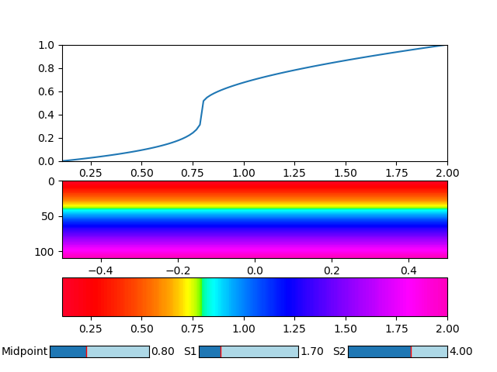

*The heatmap calibration program*

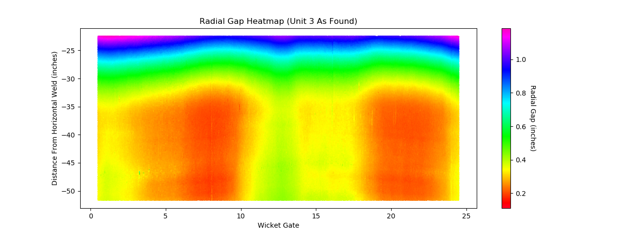

*A sample heatmap from Unit 3*

1. Save the figure

Once you have a heatmap that looks desirable, hit the save button at the bottom of the pop-up window to record it. In addition, to get individual points, hover over them. There should be an x and y position that indicates where each given point is (before saving).